Courtroom Checkpoint

The Trial Judge's (New?) Responsibilities Under the Amended Rule 702

  - Ashish Arun, Esq.
  - Principal and CEO at Expert Witness Profiler

Table of Contents
Introduction 2
Too many rubber stamps at the gate! 2
The 2000 Amendment to Rule 702 4
Road to the 2023 Amendment 6
Conclusion 8

Introduction
“The standard is the standard.”
- Mike Tomlin, Head Coach (Pittsburgh Steelers)
A key role of Courts is to determine the admissibility of parties’ evidence before it is presented to the jury. Such evidence needs to satisfy the technical requirements of the evidentiary Rules, which embody certain legal and policy determinations. Federal Rule of Evidence 104(a) clearly specifies that preliminary questions concerning the admissibility of evidence shall be determined by the Court. Unfortunately, the Rules did not (until now) define the standard of proof the Court must observe in resolving these questions.
On December 1, 2023, an amendment to the Federal Rule of Evidence 702 will come into effect, which will likely have a deep impact on how Courts deal with experts and determine whether an expert’s opinion and/or testimony are worthy of being presented to the jury. This Amendment, along with its predecessors from 2000 and 2011, is primarily aimed at clarifying the intent of the legislature and the Supreme Court’s interpretation of Section 702 in Daubert v. Merrell Dow Pharmaceuticals, Inc., 509 U.S. 579 (1993),. However, it has also been proposed in response to concerns that trial judges abdicate their duty as testimony gatekeepers by letting expert opinions through to the jury by holding that challenges emphasized the weight instead of the admissibility of expert opinions. Several stakeholders have expressed concern about this trend and favor for how the new rule is expected to “clamp down on inordinately generous gatekeeping. ” In order to further understand the upcoming amendment, we must look at Rule 702’s origin story and the subsequent amendments made in 2000 and 2011.

Too many rubber stamps at the gate!
Originally, the Frye standard required that expert opinions are “generally accepted” in the scientific community for the opinions to be admissible. The standard received criticism for obstructing the use of dependable methodologies in judicial proceedings, primarily because the larger judicial(?) community had not caught up yet.
In 1975, with the original adoption of the Federal Rules of Evidence, Rule 702 came into effect. In its original form, Rule 702 only required that the expert testimony from a qualified expert should assist the trier of fact. During the 80s, the general rule was to determine questions regarding helpfulness of an expert’s testimony “in favor of admissibility”. Eventually, as toxic and other mass tort litigation increased, “many courts ultimately determined that much of this litigation relied on causation theories that were not supported by sound scientific evidence”.
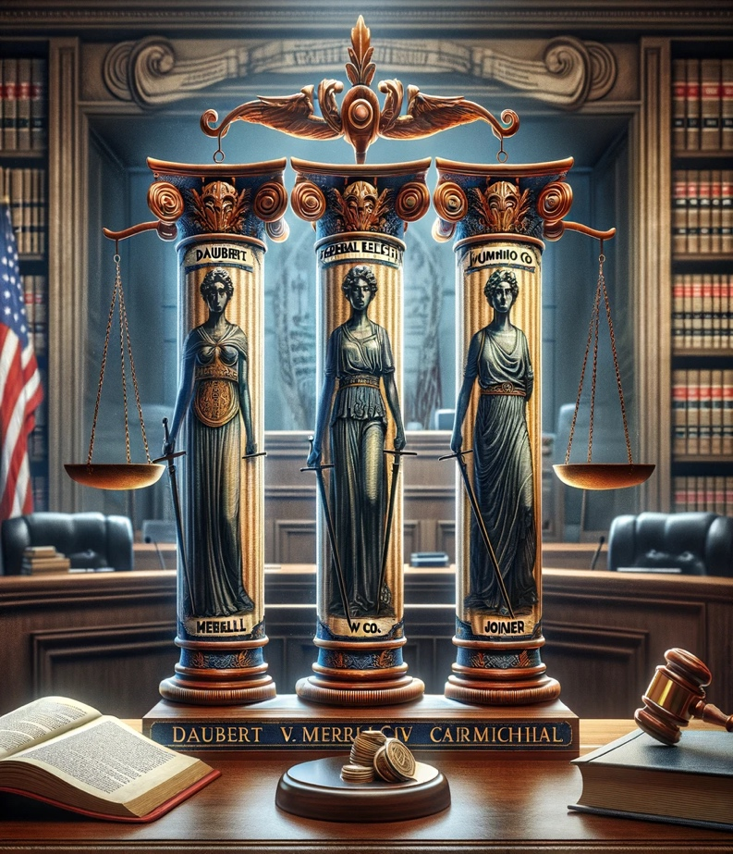
The Supreme Court intervened and issued three decisions which formed the Daubert Trilogy. In the first one, the Court ruled that the "general acceptance" test established in Frye v. United States (1923) was superseded by the Federal Rules of Evidence, particularly Rule 702; and tasked judges as gatekeepers" to assess the relevance and reliability of the expert's methods and reasoning. In the second one, the Court held that trial judges had more discretion and control over the admission of expert testimony and that the standard to review the trial court’s decision was for “abuse of discretion”.
The Daubert Trilogy, image generated using DallE3 by OpenAI

Finally, in Kumho Tire (1999), the Supreme Court extended the Daubert standard beyond scientific testimony to all expert testimony, including technical and other specialized knowledge.
Bernstein notes, “The profound changes to the traditional laissez-faire law of expert testimony provoked resistance from some federal judges who favored more liberal rules of admissibility. These judges rejected the early precedents excluding expert testimony from toxic torts cases of the late 1980s, applied Daubert narrowly in the mid-1990s, and, in the late 1990s, exploited loopholes and ambiguities in Joiner and Kumho Tire to admit questionable expert testimony.

The 2000 Amendment to Rule 702
Rule 702, in its new avatar, then required “helpful” testimony to be based on sufficient facts or data, to be a product of reliable principles and methods and for the expert to apply the principles and methods reliably to the facts of the case. In the same year, David L. Faigman, the current Chancellor and Dean of University of California Hastings College of the Law, described the Daubert decision as a “revolutionary event” and went on to note in 2013 that the revolution had been more chaotic and had taken longer to solidify than he expected.
At this point, it becomes important to understand:
- what the Daubert trilogy and the subsequent amendment of 2000 hoped to achieve,
- why there was a judicial resistance to the amended Rule 702 and
- how all of the changes have now brought us to the new amendment, which many call a mere clarification, but has the potential to finally manage the chaos that Faigman noted in his article.
What the Supreme Court wanted to achieve with the Daubert trilogy was later clarified by the Court itself in Weisgram in the year 2000. In the words of Justice Ginsburg,
“Since Daubert [. . .] parties relying on expert evidence have had notice of the exacting standards of reliability such evidence must meet. It is implausible to suggest, post-Daubert, that parties will initially present less than their best expert evidence in the expectation of a second chance should their first try fail. We therefore find unconvincing [the plaintiffs’] fears that allowing courts of appeals to direct the entry of judgment for defendants will punish plaintiffs who could have shored up their cases by other means had they known their expert testimony would be found inadmissible.”
Moreover, Rule 702, with its 2000 amendment, codified the Supreme Court’s ruling in Daubert and maintained that the judge’s gatekeeping role extends to all expert evidence and required the evidence to be sufficiently reliable and were reliably applied to the particular case. While most judges began complying with the new Rule 702, many continued to cases preceding the 2000 amendment and even pre-Daubert case law, ignoring the language of Rule 702.
Probably the first case which laid the foundation of a new reality in the post 2000 amendment world came within a year from the Eighth Circuit. In Bonner v. ISP Technologies, it was noted by Wollman, Chief Judge,
“As a general rule, the factual basis of an expert opinion goes to the credibility of the testimony, not the admissibility, and it is up to the opposing party to examine the factual basis for the opinion in cross-examination. Only if the expert's opinion is so fundamentally unsupported that it can offer no assistance to the jury must such testimony be excluded.”
However, the most emphatic opinion resisting the new order came from the First Circuit, almost a decade after Bonner, in Milward v. Acuity Specialty Products Group, Inc. After the district judge had found that the general causation evidence proffered at trial was inadmissible under Rule 702, the appellate court remanded the case and ordered that the evidence be admitted. In ordering so, the First Circuit noted,
“‘When the factual underpinning of an expert’s opinion is weak, it is a matter affecting the weight and credibility of the testimony—a question to be resolved by the jury.”
In his 2013 article, Bernstein wondered how influential the decision in Milward would turn out to be! Dwelling on the judge’ willingness or unwillingness to strictly scrutinize expert testimony, Bernstein suggests that it could track their general view of judge/ jury responsibilities.
Two years later, Bernstein wrote an article making a call for another Amendment to Rule 702 on the ground that many Courts continued to resist their proper gatekeeping role and either ignored or reinterpreted the mandate of the Rule.
Michael G. Kaplan, an expert witness with more than 40 years of experience consulting and testifying for both Plaintiffs and Defendants, agrees. In a recent podcast, Kaplan told me that, “what has happened more times than it should is that judges have looked at the expert’s report and the motion to exclude and have noted that it’s a matter of weight and I will allow the jury to hear this evidence and decide what they are going to do with it”.
Listen to the full episode here
Bernstein further notes that while it appears that cases from the Second, Third and Sixth Circuits properly understand and apply Rule 702; those from other circuits tend to hold that ““[t]he soundness of the factual underpinnings of the expert’s analysis and the correctness of the expert’s conclusions based on that analysis are factual matters to be determined by the trier of fact.”

Fifteen years after the amendment in 2000, Bernstein proposed the following amendment to Rule 702:

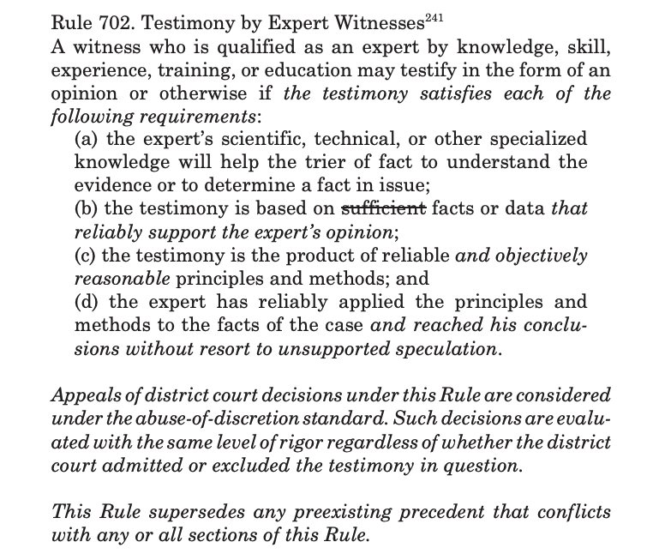

Road to the 2023 Amendment
The proposed rule reads as follows (additions are underlined; omissions are struck through):
A witness who is qualified as an expert by knowledge, skill, experience, training, or education may testify in the form of an opinion or otherwise if the proponent demonstrates to the court that it is more likely than not that:
(a) the expert’s scientific, technical, or other specialized knowledge will help the trier of fact to understand the evidence or to determine a fact in issue;
(b) the testimony is based on sufficient facts or data;
(c) the testimony is the product of reliable principles and methods; and
(d) the expert has reliably applied expert’s opinion reflects a reliable application of the principles and methods to the facts of the case.
If we look at the language of the amended Rule, it is clear that the party presenting expert evidence has the burden of proof under this section, and that burden is the “preponderance of the evidence” standard as envisaged in Rule 104. The second change is the requirement that the expert not only reliably applies but their opinion also reflects the reliable application of the principles and methods to the facts of the case.
Tarver and Younker rightly note that the new amendment language for Rule 702 leaves no ambiguity that the court is the gatekeeper between the jury and unreliable expert witnesses by compelling the court to take an active role in analyzing the methods and principles on which the expert witness relied on.
In the Report of the Advisory Committee on Evidence Rules, Judge Schiltz explained that it is not appropriate for Rule 702 determinations to be punted to the jury, but judges often do so. The second issue in consideration by the Advisory Committee was experts overstating the strength of the conclusions that can reasonably be drawn by the application of their methods to the facts. In May 2021, the Committee gave final approval and noted that it favored a slight change to existing Rule 702(d) that would emphasize that the court must focus on the expert’s opinion, and must find that the opinion proceeds from a reliable application of the methodology.

The amendments were submitted to the U.S. Supreme Court in October 2022, and on April 24, 2023, the Supreme Court forwarded the revised versions to Congress. According to 28 U.S.C. § 2074(a), these revisions are set to become effective on December 1, 2023, unless Congress enacts legislation to the contrary.
However, even before the Advisory Committee presented these amendments to the Supreme Court, the Fourth Circuit, in Sardis v. Overhead Door Corp., 10 F.4th 268 (4th Cir. 2021), emphasized the necessity for district courts to rigorously adhere to Rule 702's explicit requirements for evidence screening and to define the specific circumstances under which a court's neglect of its screening responsibilities constitutes a significant error.
Recently, Judge Shelly D. Dick from the United States District Court for the Middle District of Louisiana noted,
“The Court must apply the familiar FRE 702 and Daubert analysis. Notably, a revision to Federal Rules of Evidence 702 is slated to become effective on December 1, 2023. The anticipated change clarifies that expert testimony may not be admitted “unless the proponent demonstrates to the court that it is more likely than not that the proffered testimony meets the admissibility requirements set forth in the rule.” Section 702(d) is being amended to include language that the “expert’s opinion reflects a reliable application of the principles and methods to the facts of the case.”
However, not all Courts seem ready to apply the new standard. Judge Kristi K. DuBose from the United States District Court for the Southern District of Alabama, in Williams v. State Farm Fire & Cas. Co., refused to apply the new amended Rule 702 and noted,
““Repeatedly, State Farm urges application of proposed amendments to Rule 702 of the Federal Rules of Evidence. (that the reliability requirements, by a preponderance of evidence standard, are questions of admissibility not credibility/weight to be decided by the judge, not the jury). On June 7, 2022, the Judicial Conference Committee on Rules of Practice and Procedure approved a proposed amendment to Rule 702, which governs the admissibility of expert witness testimony. This proposed amendment must still be approved by the U.S. Supreme Court and Congress before taking effect and will only take effect (if approved) on 12/1/23. As such, the proposed amendment is inapplicable at present. State Farm's companion argument cites Union Ins. Co. v. Blakeney Palmer Co., LLC, 2015 U.S. Dist. LEXIS 123220, 2015 WL 540788 (N.D. Ala. Sept. 16, 2015) -- a case which involved expert Hall. In that case, the court denied the motion to exclude Hall as an expert, finding that any issues with his methodology were issues of weight and credibility (not admissibility) -- matters for the jury to resolve (e.g., cross-examination). From this, State Farm argues that Union Ins. Co. was "incorrect" because of the proposed amendment to Rule 702. The Court is not persuaded at this time.”

Conclusion

As we approach the effective date of the upcoming amendment to Federal Rule of Evidence 702 on December 1, 2023, it is critical to reflect on the anticipated effects on the judicial process and the evaluation of expert testimony. The core objective of this amendment is to refine and reinforce the judiciary's gatekeeping function regarding the admissibility of expert evidence. Over the years, the evolving landscape of expert testimony has demonstrated a need for a stricter framework to determine the admissibility of such evidence, which the amendments seek to address.
The amendment aims to establish a more robust standard by requiring that the party presenting the expert evidence must satisfy the preponderance of the evidence standard. This places a more defined burden on the proponent of the evidence to demonstrate that the testimony is not only based on a reliable methodology but that the expert's application of this methodology to the facts of the case is also reliable. The consequences of this amendment are far-reaching, as it emphasizes that the admissibility of expert testimony is strictly a judicial function, not to be conflated with the jury's role in weighing evidence.
Moreover, the amendment is a direct response to judicial tendencies observed over recent years, where some courts have been too lenient in their gatekeeping role, allowing questionable expert testimonies to reach the jury. This has been especially prevalent in complex cases where the scientific or technical nature of the evidence is beyond the general knowledge of lay jurors. By clearly outlining the court's role in vetting expert evidence before it reaches the jury, the amendment seeks to prevent the dilution of the standards of proof and the integrity of the judicial process.
Looking ahead, it is anticipated that the amendment will lead to a more diligent and meticulous judicial approach in scrutinizing expert evidence. Courts will likely witness an increase in pretrial challenges to expert testimony, necessitating judges to engage more deeply with the methodologies and principles underlying such evidence. While some resistance to the new standard is expected, as evidenced by some courts' reluctance to pre-emptively adopt the amended rule, the overall trajectory points toward a heightened standard that will likely result in more reliable and scientifically sound expert testimony being presented in court.
In conclusion, the amendment to Rule 702 is not merely a clarification, but a pivotal turning point in the evidentiary standards that govern expert testimony. Its successful implementation will require a concerted effort from the judiciary to embrace the enhanced gatekeeping role and for legal practitioners to adjust their strategies in presenting expert evidence. This amendment represents a significant step towards ensuring that only credible, reliable, and relevant expert testimony informs the decisions of juries and upholds the integrity of the judicial process.

============================== END OF ARTICLE ==============================

William John BOURJAILY, Petitioner v. UNITED STATES, 483 U.S. 171
Brett Tarver and Rebecca E. Younker identify several cases in their Spring 2023 ABA article where “federal judges have used a variety of standards when ruling on Rule 702 motions to exclude proposed expert testimony” and admitted experts because they have “appeared to be qualified”. Tarver and Younker note that while some courts have applied a wrong “liberal thrust” standard to admit experts, others have stated both the preponderance of evidence and liberal-thrust standard within the same opinion.
Civil Rules Committee Proposes to Toughen Rule 702, James M. Beck, Reed Smith
“If scientific, technical, or other specialized knowledge will assist the trier of fact to understand the evidence or to determine a fact in issue, a witness qualified as an expert by knowledge, skill, experience, training, or education, may testify thereto in the form of an opinion or otherwise.”
In re Agent Orange Product Liability Litigation, 611 F. Supp. 1267, 1279 (E.D.N.Y. 1985). Also see, (1996) "Rule 702: Testimony by Experts," Touro Law Review: Vol. 12: No. 2, Article 22. Available at: https://digitalcommons.tourolaw.edu/lawreview/vol12/iss2/22
David E. Bernstein, The Misbegotten Judicial Resistance to the Daubert Revolution, 89 Notre Dame L. Rev. 27 (2014)
Daubert v. Merrell Dow Pharmaceuticals, Inc. 509 U.S. 579 (1993)
General Electric Co. v. Joiner (1997) 522 U.S. 136 (1997)
David E. Bernstein, The Misbegotten Judicial Resistance to the Daubert Revolution, 89 Notre Dame L. Rev. 27 (2014)
David L. Faigman, The Law’s Scientific Revolution: Reflections and Ruminations on the Law’s Use of Experts in Year Seven of the Revolution, 57 WASH. & LEE L. REV. 661, 661 (2000)
David L. Faigman, The Daubert Revolution and the Birth of Modernity: Managing Scientific Evidence in the Age of Science, 46 U.C. DAVIS L. REV. 893, 895 (2013)
Weisgram v. Marley, 528 U.S. 440, 445 (2000).
David E. Bernstein, The Misbegotten Judicial Resistance to the Daubert Revolution, 89 Notre Dame L. Rev. 27 (2014) at 51
Bonner v. ISP Technologies, Inc., 259 F.3d 924, 929-30 (8th Cir. 2001)
Milward, 639 F.3d at 15
Bernstein, David Eliot and Lasker, Eric, Defending Daubert: It's Time to Amend Federal Rule of Evidence 702 (October 2, 2015). William & Mary Law Review, Vol. 57, No. 1, pp. 1-48, 2015, George Mason Legal Studies Research Paper No. LS 15-29, Available at SSRN: https://ssrn.com/abstract=2668805
ZF Meritor, LLC v. Eaton Corp., 696 F.3d 254, 294 (3d Cir. 2012); Amorgianos v. Nat’l R.R. Passenger Corp., 303 F.3d 256, 267 (2d Cir. 2002)
Milward v. Acuity Specialty Prods. Grp., 639 F.3d 11, 22 (1st Cir. 2011) (quoting Smith v. Ford Motor Co., 215 F.3d 713, 718 (7th Cir. 2000)).
Supra at xvi, page 44
Brett Tarver and Rebecca E. Younker, Proposed Amendments to Federal Rule of Evidence 702 Provide Clarification for Courts and Litigants. Available at https://www.troutman.com/insights/proposed-amendments-to-federal-rule-of-evidence-702-provide-clarification-for-courts-and-litigants-2.html

